Citizenship, Economics and Society (Secondary 1-3)
“3-minute Concept” Animated Video Clips Series:
“Green Consumption”
Teaching Guidelines

1. Title of the animated video clip: “Green Consumption”
2. Duration of the animated video clip: Around 3 minutes
3. Related CES Module: Module 1.3 Financial Education
4. Introduction of the animated video clip: The animated video clip was developed by the Personal, Social and Humanities Education Section, Curriculum Development Institute, Education Bureau. It uses daily examples and simple language to succinctly explain the concept of “Green Consumption”.
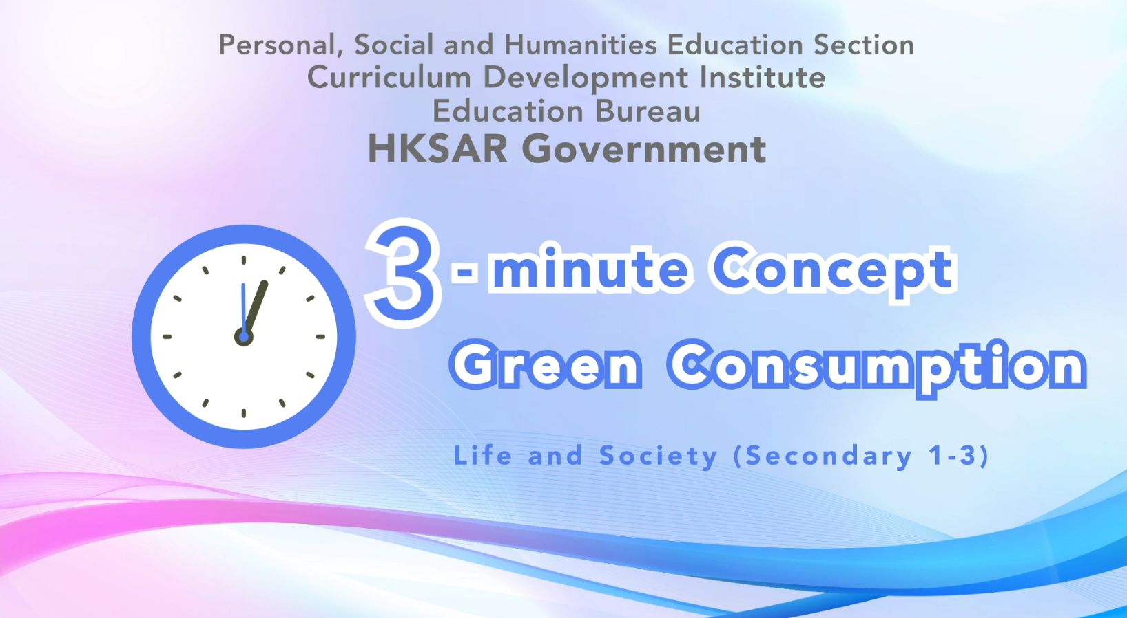
Citizenship, Economics and Society (Secondary 1-3)
Video link: https://emm.edcity.hk/media/Citizenship%2C+Economics+and+Society+%223-minute+Concept%22+Animated+Video+Clips+SeriesA+%2812%29+Green+Consumption+%28English+subtitles+available%29/1_1omi1tbj
5. Teaching tips: Teachers must explain the following main points to students after playing the “Green Consumption” animated video clip:
1) Green consumption helps promote sustainable development | Teachers should point out to students that green consumption is a mode of consumption that aims to minimise waste, protect the environment and make the best use of natural resources. When practising green consumption, the general public will consider the long-term environmental impact of the products they buy, for example, the amount of electricity consumed during production, whether clean and renewable energy or harmful substances have been used, whether the production has caused water and air pollution, etc. The change in consumer purchasing decisions will affect product supply, manufacturing and design. For example, some green consumers who are more environmentally conscious will take the initiative to purchase natural products which are not harmful to the environment and human health. This, in turn, drives companies to use environment-friendly production methods to reduce the pollution caused by economic activities, maintain ecological balance and help promote sustainable development.
2) Some shopping tips for green consumption | Teachers should point out to students that green consumption emphasises the responsibility of individuals in society and that the general public should practise green consumption in their daily lives. They should ensure that the items they buy meet their practical needs. Specific shopping tips include: preparing a shopping list before shopping so as to avoid purchasing more than needed; buying products with minimal packaging that can reduce wasting resources; reusing packaging materials such as plastic bags, paper bags, plastic boxes, paper, ribbons, etc.; participating in recycling of recyclable packaging materials; and bringing your shopping bags when shopping. For green shopping tips, please refer to the following resource:  GovHK- Green Shopping Tips  https://www.gov.hk/en/residents/environment/public/green/greenshopping.htm
3 Policies on promoting green consumption by the Government of the Hong Kong Special Administrative Region | Teachers should point out to students that the Government of the Hong Kong Special Administrative Region has been enhancing public awareness of selecting green products and promoting green consumption. Teachers can illustrate the following example to students: The Government introduced the Mandatory Energy Efficiency Labelling Scheme (MEELS) in 2008, requiring all electrical appliances supplied in Hong Kong to affix energy labels. Electrical appliances included are air-conditioners, refrigerating appliances, compact fluorescent lamps (CFLs), washing machines, dehumidifiers, televisions, storage-type electric water heaters, and induction cookers. The Scheme facilitates the identification and selection of energy-efficient appliances and raises public awareness of energy-saving. For details on the Mandatory Energy Efficiency Labelling Scheme, please refer to the following resource:  Electrical and Mechanical Services Department - Mandatory Energy Efficiency Labelling Scheme  https://www.emsd.gov.hk/en/energy_efficiency/mandatory_energy_efficiency_labelling_scheme/
4) Promoting green consumption requires the concerted efforts of society | Teachers should point out to students that apart from the government, the private sector, voluntary organisations and individuals in society can play active roles in promoting green consumption. Teachers are suggested to illustrate to students the social responsibility and specific actions of the private sector in promoting green consumption using the following example: The Hong Kong Green Building Council started the Hong Kong Green Shop Alliance Scheme in 2017, which aims to encourage shop tenants to collaborate in integrating various green initiatives into their daily operations to create a green shopping environment. For details on the Scheme, please refer to the following resource:  Hong Kong Green Shop Alliance  https://hkgsa.hkgbc.org.hk/textdisplay.php?serial=4&lang=en

6. Consolidation questions : (See next page)

“3-minute Concept” Animated Video Clips Series:

“Green Consumption”

Worksheet

A. Fill-in-the-blank questions
Put the correct answers in the spaces provided.
(Other reasonable answers are also acceptable)
- Green consumption is a mode of consumption that aims to minimise
environment
waste
, protect the and
make the best use of natural resources.
- We should shoulder personal and social responsibilities and be responsible for our consumption behaviours. Regarding personal responsibilities, when buying something, we should consider whether the goods are something that we or we
“need”
“want”
. In this way, we can avoid unnecessary waste. As for social
responsibilities, the production, transportation, sales and disposal of products will affect the environment. Consumers can encourage to improve their production and sales methods by practising green consumption.
manufacturers

B. Matching
Match the following examples with the corresponding “Green Consumption 5R” correctly by drawing a line between them.

Examples Green Consumption 5R

Reduce
Avoid consuming endangered fish and their products

Re-use
Our shopping decisions should consider the materials used in producing the product, the place of origin of the product and the production method

Rescue

Re-evaluate

Avoid buying unnecessary or excessive products
Recycle

C. Short Question
How can we protect the environment by practising green consumption?
Suggested answer: (Other reasonable answers are also acceptable)
We can choose to buy recycled products, e.g., recycled paper; or
reusable products, e.g., refillable water bottles, towels and tableware,
as far as possible.

The End

